**Climate Change Impacts on Fire Regimes, Plant Invasions and Tick-Borne Diseases**

RC-2636

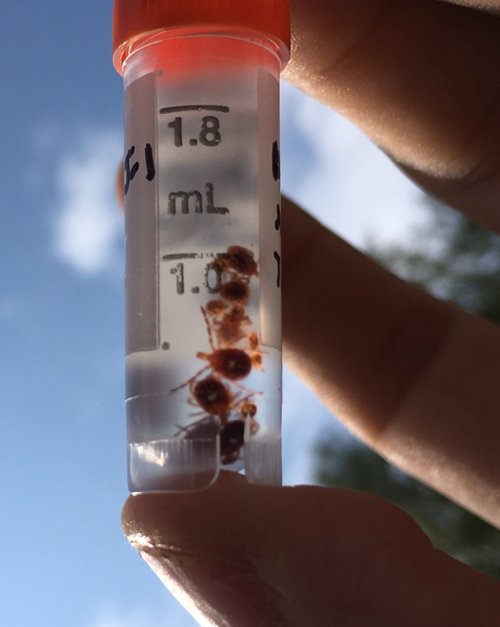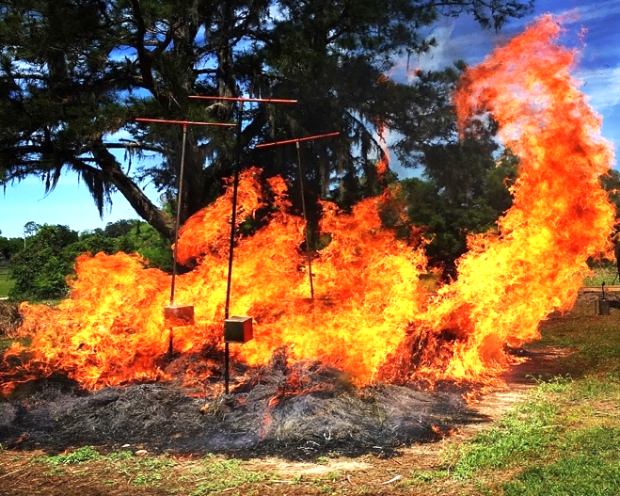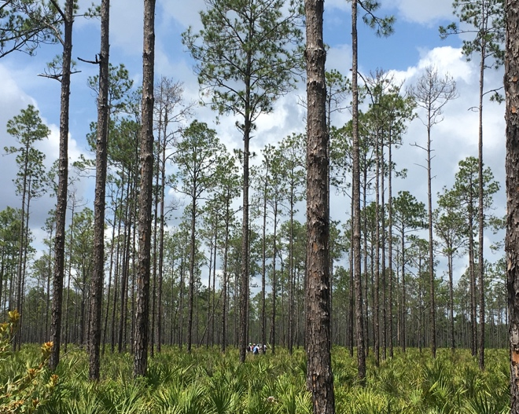

Installation Report:

**Fort Jackson**

